4 Player Pong NEA

# Analysis:

# Overview:

* I am creating a multiplayer game in which we have the regular game of pong, a game which is in essence a very simple game however I have made tweaks such that the game will contain different aspects to it that will make it that much more fun. There will be two games that occur simultaneously, with 4 players playing, and will contain block breaking which will contain power ups to enhance player’s ability or could potentially end up being disadvantageous for the player. Simultaneously this affects another game that will occur at the same time with an opposite effect. After these 2 games are finished, the remaining two will be pitted against each other and will receive points corresponding to the position in which they placed. This leads onto the ranking system which will allow users to compete against each other to see who is capable of being at the top of the game.

# Research:

Existing games: There are many version to pong that have been adapted over the years such as variations to the paddles movement allowing for rotation to an inverse pong where the players would have to guide a slot in a wall to receive the ball. I have taken a feature of the game arkanoid in which you continue to hit blocks until they break and then continue until you have successfully broken all the blocks. I have decided to take that feature but make it so there is a new way for the power ups to be attained rather than having them simply appear on the scream for the players to hit.

Problems that may arise: In-game there may be a delay between matches as when one match is over; the other player has to wait for a period of time before being able to play the final match. The manner in which I would aim to fix that is by allowing the player to play a small mini game on their side for the screen while waiting to avoid any occurrence of boredom. In addition, matches could be made to have a smaller amounts of points needed to win in order to prevent long waiting time although this may make games too short so finding the correct amount of points is necessary.

Power-ups: The ball splitting into 2, the ball’s movement changing perhaps into that of a projectile, the paddles becoming smaller, the ball moving faster, the game screen reducing in size etc.

# First Design:

I have created a general design for the layout of the game including how the in-game design looks as well as the menu. These are the initial foundation for which my game will be created upon and feature a more a newer and rustic look with the use of a neon colouring system

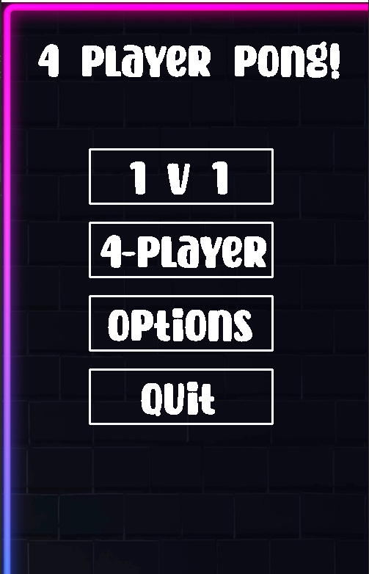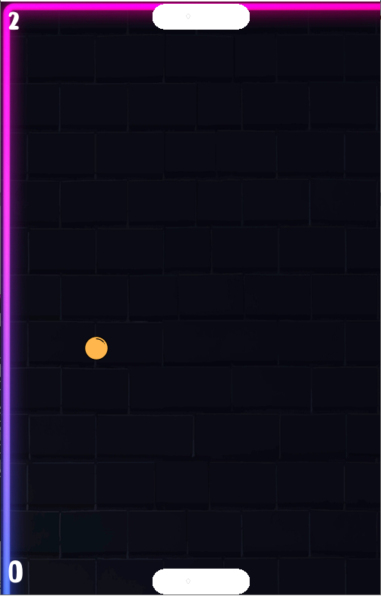

With a brick layout for a background, the game has a newer feel to it while you may be able to change the background later on with added features.

# List of objectives:

* Greet the user with an interactive menu system that allows them to choose multiple modes
* In-Game: Ball mechanics which alters the score if the ball has hit a wall on either side of the game. Implement a scoring system which presents the user with an end screen if they reach a certain score. Implement music in the background which progressively gets faster as the game progresses.
* Implement two screens at once with games happening simultaneously
* Implement power ups that will require breaking blocks and simultaneously affect the other game dependent on the power up
* Update the players score to a ranking system in which they will be able to complete with other players to see who can achieve the highest score.

# Links for research:

<https://www.raywenderlich.com/2614-multiplayer-game-programming-for-teens-with-python-part-1>

<https://www.youtube.com/watch?v=a_YTklVVNoQ&list=WL&index=6&ab_channel=DaFluffyPotato>